Hierarchical State Machine
In this article, we will be highlighting the advantages of hierarchical state machine design over conventional state machine design.
在这篇文章中我们将在传统的状态机设计上探讨层次型状态机的设计.
In conventional state machine design, all states are considered at the same level. The design does not capture the commonality that exists among states. In real life, many states handle most messages in similar fashion and differ only in handling of few key messages. Even when the actual handling , there is still some commonality. Hierarchical state machine design captures the commonality by organizing the states as a hierarchy. The states at the higher level in hierarchy perform the common message handling, while the lower level states inherit the commonality from higher level ones and perform the state specific functions. The table given below shows the mapping between conventional states and their hierarchical counterparts for a typical call state machine.
在传统的状态机设计中,在相同的层次下考虑所有的状态.这种设计不注意状态(exists among states)的共性.在真实生活中,许多的状态用相同的方式处理大多数的消息,仅在处理少数不同的消息时以不同方式处理.当实际处理这些不同事件时,他们仍然有一些共性.层次型状态机设计时关注这些共性并组织成一个层次.当底层的状态从高层当中一个状态继承共性并执行这个状态特定功能时,在层次中的高层状态执行公共的消息处理.下表显示了会话状和他们相应层的一个典型调用的状态机
Conventional States | Hierarchical States
Awaiting First Digit | Setup.CollectingDigits.AwaitingFirstDigit
Collecting Digits | Setup.CollectingDigits.AwaitingSubsequent Digits
Routing Call | Setup.RoutingCall
Switching Path | Setup.SwitchingPath
Conversation | Conversation
Awaiting Onhook | Releasing.AwaitingOnhook
Releasing Path | Releasing.ReleasingPath
A conventional state machine is designed as a two dimensional array with one dimension as the state and the other dimension specifying the message to be handled. The state machine determines the message handler to be called by indexing with the current state and the received message. In real life scenario, a task usually has a number of states along with many different types of input messages. This leads to a message handler code explosion. Also, a huge two dimensional array needs to be maintained. Hierarchical state machine design avoids this problem by recognizing that most states differ in the handling of only a few messages. When a new hierarchical state is defined, only the state specific handlers need to be specified.
一个传统的状态机的设计是一个二维表,一维是状态,一维是可以处理的消息. 状态机通过查找当前状态与接收的消息来决定消息的处理器的调用.在真实生活剧本中,一个任务通常有一个状态的数目和许多不同的输入消息类型.它将导致处理代码的激增(code explosion).所以需要维护一个巨型的二维表.层次型的状态机设计通过识别大多数状态在处理仅少数消息时不同, 避免了这个问题.当一个新的层次状态被识别,这个状态仅要指定少数的处理器.

Conventional State Machine Example
The figure below describes the state transition diagram for an active standby pair. The design here assumes that the active and standby are being managed by an external entity.
下面的状态转换图指示了一个”Active”与”Standby”状态对.这个设计假定”Active”与”Standby”被一个外部实体管理
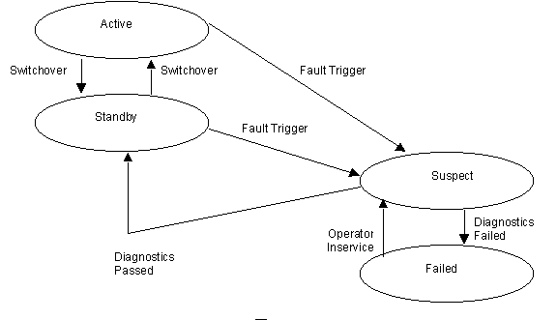
The different states for the state machine are Active, Standby, Suspect and Failed. The input messages to be handled are Switchover, Fault Trigger, Diagnostics Passed, Diagnostics Failed and Operator Inservice. Thus the handler two dimensional array is 4 x 5 i.e. 20 handlers need to be managed.
对状态机来说有四不同的状态Active, Standby, Suspect 和 Failed.输入消息被Switchover, Fault Trigger, Diagnostics Passed, Diagnostics Failed 和 在职的操作员处理.然而处理器二维矩阵有 4 x 5 个处理器要管理.
The code below shows the handlers that need to be defined. A dummy "do nothing" handler should be specified for all other entries of the two dimensional state table. This simple example clearly illustrates the problem with conventional state design. There is a lot of code repetition between handlers. This creates a maintenance headache for state machine designers. We will see in the following section that hierarchical state machine design exploits these very similarities to implement a more elegant state structure.
下列代码展示了需要定义的处理器. 一个空(dummy)”do nothing”处理器被指定给二维状态表中所有实体,这个简单的例子干净地展示了传统状态设计的问题.在处理器之间有许多的代码重复.在下节中我们将看到层次型状态机设计的运用,他们非常简单的实现了一个更多简炼的状态结构
Conventional State Machine Implementation
/* == Active State Handlers == */
void ActiveStateFaultTriggerHandler(Msg *pMsg)
{
PerformSwitchover(); // Perform Switchover, as active failed
NextState = SUSPECT; // Run diagnostics to confirm fault
SendDiagnosticsRequest();
RaiseAlarm(LOSS_OF_REDUNDANCY); // Report loss of redundancy to operator
}

void ActiveStateSwitchoverHandler(Msg *pMsg)
{
PerformSwitchover(); // Perform Switchover on operator command
CheckMateStatus(); // Check if switchover completed
SendSwitchoverResponse(); // Inform operator about switchover
NextState = STANDBY; // Transition to standby
}

/* == Standby State Handlers == */
void StandbyStateFaultTriggerHandler(Msg *pMsg)
{
NextState = SUSPECT; // Run diagnostics to confirm fault
SendDiagnosticsRequest();
RaiseAlarm(LOSS_OF_REDUNDANCY); // Report loss of redundancy to operator
}

void StandbyStateSwitchoverHandler(Msg *pMsg)
{
PerformSwitchover(); // Perform switchover on operator command
CheckMateStatus(); // Check if switchover completed
SendSwitchoverResponse(); // Inform operator about switchover
NextState = ACTIVE; // Transition to active
}

/* == Suspect State Handlers == */
void SuspectStateDiagnosticsFailedHandler(Msg *pMsg)
{
SendDiagnosticsFailureReport(); // Inform operator about diagnostics
NextState = FAILED; // Move to the failed state
}

void SuspectStateDiagnosticsPassedHandler(Msg *pMsg)
{
SendDiagnosticsPassReport(); // Inform operator about diagnostics
ClearAlarm(LOSS_OF_REDUNDANCY); // Clear loss of redundancy alarm
NextState = STANDBY; // Move to standby state
}

void SuspectStateOperatorInservice(Msg *pMsg)
{
// Operator has replaced the card, so abort the current diagnostics
// and restart new diagnostics on the replaced card.
AbortDiagostics();
SendDiagnosticsRequest(); // Run diagnostics on replaced card
SendOperatorInserviceResponse(); // Inform operator about diagnostics start
}
/* == Failed State Handlers == */
void FailedStateOperatorInservice(Msg *pMsg)
{
SendDiagnosticsRequest(); // Run diagnostics on replaced card
SendOperatorInserviceResponse(); // Inform operator about diagnostics start
NextState = SUSPECT; // Move to suspect state for diagnostics
}

Hierarchical State Machine Example
The following state transition diagram recasts the state machine by introducing two levels in the hierarchy. Inservice and Out_Of_Service are the high level states that capture the common message handling. Active and Standby states are low level states inheriting from Inservice state. Suspect and Failed are low level states inheriting from Out_Of_Service state.
下列状态转换图通过引入了两个层次改造了状态机. Inservice 和OutOfService是两个关注公共消息处理的高层状态. Active 和 Standby 是继承自Inservice状态的两个底层状态. Suspect和 Failed是继承自OutOfService状态的两个底层状态.
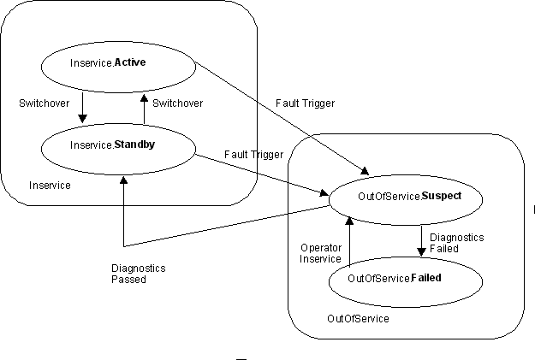
The following diagram clearly illustrates the state hierarchy. Even the Inservice and Out_Of_Service, high level states inherit from the Unit_State that is at the highest level.
下图干净的展示了状态的层次.甚至Inservice 和 OutOfService两个高层也继承自更高层的 Unit_State
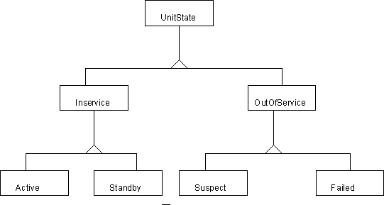

Hierarchical State Machine Source Code
The C++ implementation details of the hierarchical state machine are given below. It is apparent that all the commonality has moved to the high level states viz. Inservice and Out_Of_Service. Also, contrast this with the conventional state machine implementation.
C++的实现细节在下面给出了.它展示了被移到高层的共性. Inservice 和 Out_Of_Service.请对比一下传统的状态机实现.
The code below contains hyperlinks to more detailed information about the classes, methods and variables in this information.

Header File
The header file below declares the Unit state machine using the Hierarchical_State_Machine class. Important points to note are:
下面的头文件在Hierarchical_State_Machine 类中申明了 Unit state.需要注意的重点是:
- The state classes are nested private classes within the state machine class. Thus they are not visible to other classes.
- 状态类是状态机类的嵌套私有类,它们对外部类是不可见的.
- The state machine declares all states to be friend classes. This does not break the encapsulation as only a private class is being declared as a friend.
- 状态机申明了所有的状态为友元的.将一个私有类申明为友元不会打破封装的.
- The base class (Unit_State) provides a "do nothing" implementation for all handlers. Thus an inheriting state has to provide an implementation only for that methods it supports.
- 基类(Unit_State)为所有的处理器提供了一个"do nothing"实现.因些一个子状态仅为它自已提供一个实现.
- State objects are declared static. Thus multiple instances of the state machine will share the same state objects. Due to this, the Hierarchical_State_Machine class has a small memory footprint.
- Only the main message handler, On_Message, is declared public. All helper functions are private.
- 状态对象被申明为静态的.因些多个状态机实例可以共享相同的状态对象.因为这个, Hierarchical_State_Machine 类占用很少的内存.
- A pointer to the current state is maintained in p_Current_State variable. This variable gets initialized using the Next_State method.
- 指向当前状态的指针保存在p_Current_State变量中,这个变量用Next_State 方法初始化.

Hierarchical_State_Machine.h
00001
00002 class Message;
00009
00010
00011
00031
00032 class Hierarchical_State_Machine
00033 {
00037
00038 class Unit_State
00039 {
00040 public:
00041
00043 virtual void On_Switchover(Hierarchical_State_Machine &u,
const Message *p_Message) {}
00044
00046 virtual void On_Fault_Trigger(Hierarchical_State_Machine &u,
const Message *p_Message) {}
00047
00049 virtual void On_Diagnostics_Failed(Hierarchical_State_Machine &u,
const Message *p_Message) {}
00050
00052 virtual void On_Diagnostics_Passed(Hierarchical_State_Machine &u,
const Message *p_Message) {}
00053
00055 virtual void On_Operator_Inservice(Hierarchical_State_Machine &u,
const Message *p_Message) {}
00056 };
00057 friend Unit_State;
00058
00059
00062
00063 class Inservice : public Unit_State
00064 {
00065 public:
00066 void On_Switchover(Hierarchical_State_Machine &u,
const Message *p_Message);
00067 void On_Fault_Trigger(Hierarchical_State_Machine &u,
const Message *p_Message);
00068 };
00069 friend Inservice;
00070
00075
00076 class Active : public Inservice
00077 {
00078 public:
00079 void On_Switchover(Hierarchical_State_Machine &u,
const Message *p_Message);
00080 void On_Fault_Trigger(Hierarchical_State_Machine &u,
const Message *p_Message);
00081 };
00082 friend Active;
00083
00088
00089 class Standby : public Inservice
00090 {
00091 public:
00092 void On_Switchover(Hierarchical_State_Machine &u,
const Message *p_Message);
00093 };
00094 friend Standby;
00095
00098
00099 class Out_Of_Service : public Unit_State
00100 {
00101 public:
00102 void On_Operator_Inservice(Hierarchical_State_Machine &u,
const Message *p_Message);
00103 };
00104 friend Out_Of_Service;
00105
00109 class Suspect : public Out_Of_Service
00110 {
00111 public:
00112 void On_Diagnostics_Failed(Hierarchical_State_Machine &u,
const Message *p_Message);
00113 void On_Diagnostics_Passed(Hierarchical_State_Machine &u,
const Message *p_Message);
00114 void On_Operator_Inservice(Hierarchical_State_Machine &u,
const Message *p_Message);
00115 };
00116 friend Suspect;
00117
00121 class Failed : public Out_Of_Service
00122 {
00123 public:
00124 // No Need to Override any other method
00125 };
00126 friend Failed;
00127
00128 private:
00129 static Active Active_State;
00130 static Standby Standby_State;
00131 static Suspect Suspect_State;
00132 static Failed Failed_State;
00133
00134 void Next_State(Unit_State &r_State);
00135
00136
00137 // Common Methods invoked from several states
00138 // (See article on FSM Inheritance for details)
00139 virtual void Send_Diagnostics_Request();
00140 virtual void Raise_Alarm(int reason);
00141 virtual void Clear_Alarm(int reason);
00142 virtual void Perform_Switchover();
00143 // . . .
00144 virtual void Send_Switchover_Response();
00145 virtual void Send_Operator_Inservice_Response();
00146 virtual void Send_Diagnostics_Failure_Report();
00147 virtual void Send_Diagnostics_Pass_Report();
00148 virtual void Abort_Diagnostics();
00149 virtual void Check_Mate_Status();
00150 Unit_State *p_Current_State;
00151
00152 public:
00153 void On_Message(const Message *p_Message);
00154 };
00155
00159
00160 void Hierarchical_State_Machine::Next_State(Unit_State &r_State)
00161 {
00162 p_Current_State = &r_State;
00163 }
00164
00165

Source File
Important things to note about the source file:
关于源文件要注意的是:
- On_Message, the main message handler invokes the appropriate handler based on the type of the message. The message is passed to the current state object.
- On_Message,主消息处理器根据消息的类型调用不同的处理器.消息中传递当前状态对象.
- The Out_Of_Service and Inservice base states handle most of the message processing. In some cases, the inheriting states perform some additonal action and call the handler for the base state for the common part of the handling.
- Out_Of_Service 和 Inservice 基状态处理大多数消息.有时.继承的状态执行想同的动作和调用

Hierarchical_State_Machine.cpp
00007
00008 #include "Hierarchical_State_Machine.h"
00009 #include "Unit_Messages.h"
00010 #include "assert.h"
00011
00016
00017 void Hierarchical_State_Machine::On_Message(const Message *p_Message)
00018 {
00019 switch (p_Message->GetType())
00020 {
00021 case Message::FAULT_TRIGGER:
00022 p_Current_State->On_Fault_Trigger(*this, p_Message);
00023 break;
00024
00025 case Message::SWITCHOVER:
00026 p_Current_State->On_Switchover(*this, p_Message);
00027 break;
00028
00029 case Message::DIAGNOSTICS_PASSED:
00030 p_Current_State->On_Diagnostics_Passed(*this, p_Message);
00031 break;
00032
00033 case Message::DIAGNOSTICS_FAILED:
00034 p_Current_State->On_Diagnostics_Failed(*this, p_Message);
00035 break;
00036
00037 case Message::OPERATOR_INSERVICE:
00038 p_Current_State->On_Operator_Inservice(*this, p_Message);
00039 break;
00040
00041 default:
00042 assert(false);
00043 break;
00044 }
00045 }
00046
00055
00056 void Hierarchical_State_Machine::Inservice::On_Fault_Trigger(
Hierarchical_State_Machine &u,
const Message *p_Message)
00057 {
00058 u.Next_State(u.Suspect_State);
00059 u.Send_Diagnostics_Request();
00060 u.Raise_Alarm(LOSS_OF_REDUNDANCY);
00061 }
00062
00070
00071 void Hierarchical_State_Machine::Inservice::On_Switchover(
Hierarchical_State_Machine &u,
const Message *p_Message)
00072 {
00073 u.Perform_Switchover();
00074 u.Check_Mate_Status();
00075 u.Send_Switchover_Response();
00076 }
00077
00088
00089 void Hierarchical_State_Machine::Active::On_Fault_Trigger(
Hierarchical_State_Machine &u,
const Message *p_Message)
00090 {
00091 u.Perform_Switchover();
00092 Inservice::On_Fault_Trigger(u, p_Message);
00093 }
00094
00100
00101 void Hierarchical_State_Machine::Active::On_Switchover(
Hierarchical_State_Machine &u,
const Message *p_Message)
00102 {
00103 Inservice::On_Switchover(u, p_Message);
00104 u.Next_State(u.Standby_State);
00105 }
00106
00112
00113 void Hierarchical_State_Machine::Standby::On_Switchover(
Hierarchical_State_Machine &u,
const Message *p_Message)
00114 {
00115 Inservice::On_Switchover(u, p_Message);
00116 u.Next_State(u.Active_State);
00117 }
00118
00127
00128 void Hierarchical_State_Machine::Out_Of_Service::On_Operator_Inservice(
Hierarchical_State_Machine &u,
const Message *p_Message)
00129 {
00130 // Operator has replaced the card, so abort the current diagnostics
00131 // and restart new diagnostics on the replaced card.
00132 u.Send_Diagnostics_Request();
00133 u.Send_Operator_Inservice_Response();
00134 u.Next_State(u.Suspect_State);
00135 }
00136
00142
00143 void Hierarchical_State_Machine::Suspect::On_Diagnostics_Failed(
Hierarchical_State_Machine &u,
const Message *p_Message)
00144 {
00145 u.Send_Diagnostics_Failure_Report();
00146 u.Next_State(u.Failed_State);
00147 }
00148
00155
00156 void Hierarchical_State_Machine::Suspect::On_Diagnostics_Passed(
Hierarchical_State_Machine &u,
const Message *p_Message)
00157 {
00158 u.Send_Diagnostics_Pass_Report();
00159 u.Clear_Alarm(LOSS_OF_REDUNDANCY);
00160 u.Next_State(u.Standby_State);
00161 }
00162
00167
00168 void Hierarchical_State_Machine::Suspect::On_Operator_Inservice(
Hierarchical_State_Machine &u,
const Message *p_Message)
00169 {
00170 u.Abort_Diagnostics();
00171 Out_Of_Service::On_Operator_Inservice(u, p_Message);
00172 }

